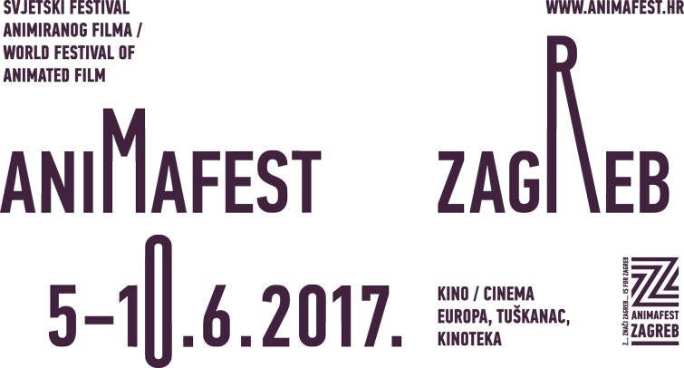


GRAND OPENING OF THE 27TH WORLD FESTIVAL OF ANIMATED FILM – ANIMAFEST ZAGREB

Zagreb, 5. June 2017 – With the opening ceremony held tonight at Europa cinema the 27th World Festival of Animated Film – Animafest Zagreb has officialy started its programme which will last from 5 - 10 June and present 350 animated films in cinemas Europa, Tuškanac and Kinoteka. Deputy Mayor of the City of Zagreb Jelena Pavičić Vukičević on behalf of the Mayor of Zagreb, Milan Bandić, opened the festival.
Zagreb has been a proud host of Animafest since 1972. and we hope it will stay that way for a long time. It makes this city a special cultural destination for all animation aficionados. Next five days will be filled with wonderful films and I hope that all screenings will be as well attended as the one today. Thank you all for coming and I hereby declare Animafest Zagreb 2017 open! – Pavičić Vukičević said.
In front of a completely packed Cinema Europa, the audience was addresed by managing director of the Croatian Audiovisual Centre Daniel Rafaelić, Animafest’s artistic director Daniel Šuljić, festival producers Matea Milić and Paola Orlić, and Festival Council president Margit Antauer.
Animafest has always been at least a bit above all the other festivals in Zagreb and Croatia. It's a festival we can all be proud of and is recognized for its quality worldwide. Its archive is truly a Who's Who of animation – with glorious past and future. What we are celebrating here is animation, talent and creativity and universal language of animation – said Daniel Rafaelić.
The Lifetime Achievement Award, at the discretion of the Animafest Council, was presented to Borivoj Dovniković – Bordo, the Award for Outstanding Contribution to Animation Studies went to Maureen Furniss. The award for the Best Animation School went to Film and TV School of Academy of Performing Arts in Prague – FAMU while The International Animated Film Association (ASIFA) gave the Award for Outstanding Contribution to the Art of Animation to Jean-François Laguionie.
The award for the Best Animation School was presented to Michaela Pavlátová, a professor of animation at Film and TV School of Academy of Performing Arts in Prague (FAMU) and a member of the Grand Competition – Short Film jury.
I am very proud to receive this award on behalf of my school because I know that we received it among great competition of other animation schools wordwide. I hope this award will serve as an incentive for our students to continue working hard and be successful - said Michaela Pavlátová, an Academy Award nominee for Words, Words, Words. A special retrospective of FAMU films will be screened on Friday, 9 June in Cinema Tuškanac at 15:30.
Zagreb School of Animated Films master of animation Borivoj Dovniković – Bordo, after Dušan Vukotić only the second Croatian recipient of this prestigious award said:
Of all the awards I've received in the last 50-60 years, only now have I recieved the one that is my favourite – Our festival award, the one I've helped establish all those years ago. I am happy to receive it in the same exact place where we premiered our first animated feature film - the one I've also worked on, The Great Meeting in 1951.
The retrospective programme Masters of Animation featuring Borivoj Dovniković-Bordo's films will take place on Tuesday, 6 June in Cinema Europa at 15:30.
ASIFA Award for Outstanding Achievements in The Art of Animation was presented by members ASIFA committee, Sayoko Kinoshita, Jonchill Lee, Nancy Phelps and Vesna Dovniković to grandmaster of French animation, Jean-François Laguionie, a perfectionist author of lavish features of unique colours. His new feature film Louise by the Shore will be screened as part of Animafest Grand Competition – Feature Film on Tuesday, 6 June 17:30 at Cinema Europa and on Saturday, 10 June at 11:00 at Cinema Tuškanac.
Persistance, perseverance and sincerity are the keys to the art of animation – said Laguionie.
American animation historian Maureen Furniss expressed her gratitude for receiving the Award for Outstanding Contribution to Animation Studies and said that her first visit to Animafest 20 years ago opened her eyes to the truly global nature of world animation.
I am really grateful for this award because animation historian's job is generally a solitary affair so it's nice to be recognized for your work - said Furniss. Furniss will also be this year's keynote speaker at the Animafest Scanner IIII symposium, which will take place on 6 and 7 June between 10:00 and 17:00 in Chilloutka (Ilica 15/1).
The ceremony ended with the screening of films from the Grand Competition – Short Film 1 and talks with their authors Antje Heyn (Trial and Error), Eva Cvijanović (Hedgehog's Home) and Anete Melece (Analysis Paralysis). After the ceremony, DJ Mario Kovač entertained Animafest’s guests at the party in Story Supercaffe.
From recent works to masterpieces of the past, in the next five days Animafest Zagreb 2017 will cover all areas of animation in its competitions, theme programmes and retrospectives, while focus this year will be on the connection between comic book and animation.
With many side events like exhibitions, workshops, lectures, symposium, school presentations, book presentations, site-specific films, open-air events in the city streets and parks, Animafest 2017 will host more than 200 distinguished guests from all over the world. Among them is an Academy Award and Animafest Grand Prix winner, Michaël Dudok de Wit (both for Father and Daughter), a Dutch world class director and three times Oscar nominee, the latest of which, The Red Turtle, is screened in Grand Competition – Feature Film (Wednesday 7 June, 20:00 at Kinoteka and Thursday 8. June, 17:30 at Cinema Europa), and who is also having a masterclass in Zagreb (Saturday 10 June, 10:30 in KIC). One of the most original personalities on the global animation scene, Rosto, Dutch director, musician, visual artist and comic book author, will be part of Animafest's Grand Competition – Short Film jury an is having a retrospective at Animafest 2017 in the Masters of Animation section (Wednesday 7 June, 15:30, Cinema Europa and Friday 9 June, 22:00 Cinema Tuškanac) and will also have a rare mastreclass (Friday 9 June, 10:30, KIC). Sensational Annecy winner Dahee Jeong will also present her new film The Empty.

*******************************************************

Prior to today's Grand Opening of the 27th World Festival of Animated Film – Animafest Zagreb, this Monday 5 June at 12:00 a group exhibition of recent student works from the Academy of Fine Arts Zagreb, Department of Animation and New Media (OZAFIN ALU) was opened at Šira Gallery. Milan Trenc, Chair of the Department of Animation and New Media, ALU Zagreb, opened the exhibition. The selection of films aims to present a snapshot of what the Department of Animation and New Media looks like now and best works by its students in many different techniques.
At 15:00 an expanded animation installation Bioscope by Maarten Isaäk De Heer (animated painting in the style of painters like Pieter Bruegel the Elder and Hieronymus Bosch made possible by impressive technique called lenticular printing) and Animation and VR (a selection of films in virtual reality produced by Google Spotlight Story – Pearl by Oscar awarded filmmaker Patrick Osborne, and music video Saturnz Barz by Gorillaz as well as Canadian NFB production Minotaur by Munro Ferguson, made by using the world's first freehand stereoscopic 3D animation software) was opened in Tunnel Grič.
At 21:30, Ljetno kino Gradec screened Corto Maltese in Siberia, an adaptation of one of the canonical albums about the comic book medium's most famous sailor.

PHOTOGRAPHIES FROM GRAND OPENING OF ANIMAFEST 2017
http://bit.ly/2sadrnl

MORE INFORMATION
http://www.animafest.hr
www.facebook.com/AnimafestZagreb
https://twitter.com/Animafest_Zg
https://www.instagram.com/animafestzg/
https://vimeo.com/animafestzagreb

