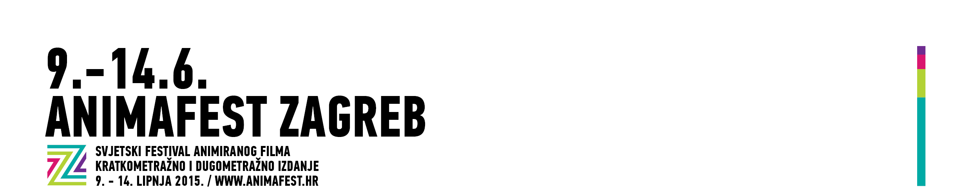

INTERVIEW REQUEST

NAME AND SURNAME OF THE JOURNALIST
______________________________________________________________

NAME OF THE MEDIA, DEPARTMENT
______________________________________________________________

CONTACT (MOBILE PHONE, E-MAIL)
______________________________________________________________

NAME AND SURNAME OF THE GUEST FOR INTERVIEW
______________________________________________________________

WANTED TIME (date, hour) AND DURATION OF INTERVIEW
______________________________________________________________

* We strongly advise you to keep your time schedules! If there's going to be any changes in your time schedule, please notify us in advance. Interviews are taking place in festival's Press center in Cinema Europa. Note: submission of this request does not guarantee it's confirmation.
***
Media contact:
Jelena Androić, Head of Media department
press@animafest.hr
+385 91 590 49 05

