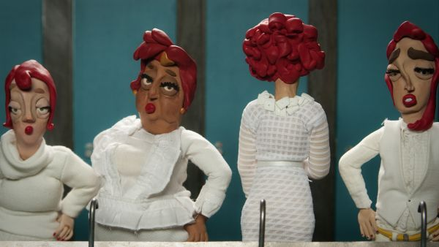
PRESS RELEASE

Meet the future of animation: from training to gaming

What does the future of animation look like? This year’s Animafest offers as many as six answers to this question – a competition of the youngest generation of filmmakers, a presentation of the finest animation schools, a collaboration with the Croatian Game Developers Association, and a game jam workshop mentored by the Swiss star of indie game design – Mario von Rickenbach!

ZAGREB, 6 May 2015 - From social networks, to mobile phones, television and films, animation today is omnipresent. If you would like to know what it will look like in the future, and who are its finest young authors and what they are doing, don’t miss this year’s Animafest student film competition. Out of 640 submitted entries, the programmers chose 43 of them from 19 countries, which use CGI and 3D animations, mixed media and puppets to give a new glimpse on the animation world. For the first time this entire programme segment is free of charge, thanks to Erste bank’s Urbanka, also the sponsor of Dušan Vukotić Award.
Apart from the competition, students from all over the world will gather in mini-retrospective programmes of two leading animation schools. The first, Bezalel Academy of Arts and Design from Jerusalem has been known as one of the most prestigious schools of animation ever since the 1970s, with a branched student exchange programme. The second – the French ‘wonder of Arles’ – is MOPA, specializing in CGI, a school whose alumni include over 400 students, 95 per cent of which were hired immediately after graduating. Some of them work in global computer game industry, which has long surpassed film and music industry by its total value. Aside from advanced technology, the key element of game development is precisely – animation.
With that in mind, Animafest in association with the Faculty of Electrical Engineering and Computing, Academy of Fine Arts, and Creative Europe Desk – MEDIA Office, for the third year organizes a gamejam, i.e. computer game design workshop. One of this year’s mentors will be the Swiss star of indie game design – Mario von Rickenbach (Mirage, Krautscape, Rakete)!
However, like other creative industries, gaming development needs business support and know-how, and this is what Animafest this year offers for the first time in association with the Croatian Game Developers Association (CGDA). This is a cluster that gathers more than 20 companies with over 200 developers and exports almost 99 per cent of their products, like the cult FPS (first person shooter) hit – Serious Sam by Croteam, or Ironward’s ever more popular Red Solstice.
By connecting the programmer, animator and illustrator community in this part of the programme, Animafest Pro fosters creativity and competitiveness of young artists and IT experts and gives them a chance to get to know the transmedia connection between animation and computing.
Gamejam participants will work in small designer-programmer teams between 8 and 12 June to develop their own videogame and present it on the penultimate day of the festival, after a lecture by CDGA, a local team of developers Croteam, Machina game design school and the already mentioned Mario von Rickenbach.
This entire segment of Animafest’s programme is completely free of charge and workshop applications are to be sent online, on the official festival website, by 24 May.

***
Student film competition
Wednesday, 10/6 | 17:30 h | Tuškanac cinema
Thursday, 11/6 – Sunday, 14/6 | 11:00 h | Tuškanac cinema

Lectures
CGDA, CroTeam, Machina
Friday, 12/6 15:30, Tuškanac cinema
Mario von Rickenbach& presentation of gamejam results
Saturday, 13/6 15:30, Tuškanac cinema

***
Press kit download (via BOX or press directory):
BOX https://goo.gl/UweCWG
WEB http://animafest.hr/hr/2015/press/media

More on:
http://www.animafest.hr
***
Media contact:
Jelena Androić, media relations manager
press@animafest.hr
+385 91 590 49 05

