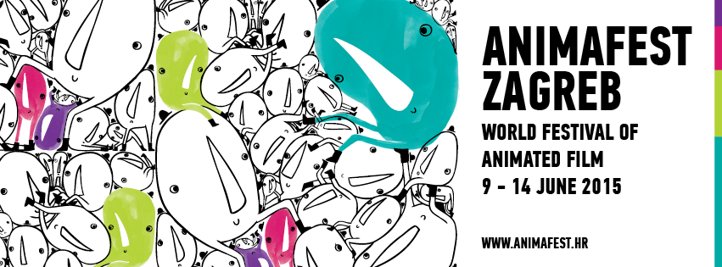

PRESS RELEASE

Presenting the 25th Animafest Zagreb Festival Visuals and Trailer!

- The author of this year’s festival visuals and trailer is Petra Zlonoga, Croatian animator, designer and illustrator

Zagreb, 31 March 2015 – This year’s Animafest Zagreb festival visuals and trailer is the work of Croatian animator, designer and illustrator Petra Zlonoga. The festival's visual identity is again, like last year, the work of the Kuna zlatica designer team.

Petra Zlonoga (1982) graduated in graphic design from the Faculty of Design in 2007, and in animated film and new media from the Zagreb Academy of Fine Arts in 2011. She first attracted attention with her student works, films Daniil Ivanovich, Marry Me (2007), Gregor (2010), Fox (2010), and Daniil Ivanovich, You’re Free (2011). Her first professional film Hunger (2014) screened at many important animation festivals globally, including Ottawa International Animation Festival, London International Animation Festival and Tricky Women Festival in Vienna.

“To all of us at Animafest it is an extreme joy to support and call attention to Croatian filmmakers who are slowly taking the animation torch and continuing the success stories of the Zagreb Animation School,” said Animafest’s artistic director Daniel Šuljić about Zlonoga.

Animafest Zagreb was established in 1972, which makes it the second oldest European festival dedicated exclusively to animation. For four decades now it has been considered one of the leading world animation events, and its 25th edition, taking place 9-14 June 2015, for the first time merges the short and the feature edition and presents animated films of all durations.

Trailer:
YouTube

Petra Zlonoga’sVimeo:
https://vimeo.com/petrazlonoga

Press kit download (via BOX or press directory):
BOX http://goo.gl/1kxGew
WEB http://animafest.hr/en/2015/press/media

More information:
http://www.animafest.hr
***
Media contact:
JelenaAndroić, media relations manager
press@animafest.hr
+385 91 590 49 05

Ana Mikin, PR and promotion manager
ana.mikin@gmail.com
+385 95 1984 720

